Phase 3 Martin Home Lab
Configure LAN and Internet
Enterprise Network Project
Jul 3, 2026

Configure LAN and Internet

After the Installation of pfSense was Complete, now I will verify connectivity to the LAN and WAN internet. This phase will go over Configuration (WAN, LAN, DHCP, DNS), Connectivity (Switch, Laptop), Lease Obtainment, Verification (of gateway, internet and NAT). Later I will review validation and troubleshooting with lessons learned.

pfSense Initialization/Configurations Steps
- General Information - After successfully installing and booting pfSense onto the firewall/router, I now Have to configure connectivity over the network. The Hostname is pfSense, Domain is “home.arpa”, and DNS server is 1.1.1.1. Regarding DNS, I left the option “Override DNS from WAN checked so it had more flexibility with DNS choices.
- Time Server – I left the time server default as 0.pfsense.pool.ntp.org, and the time-zone is set to America/NewYork (EST)
- Configuring WAN Interface – I left the “type” as DHCP, left the MTU (Max Transmission Unit/ Max Segmentation Size” blank for now. I allowed private networks and blocked bogon networks. This is because my LAN is a private network and it would have been blocked if I left this checked
- Configuring LAN Interface – Initially I left LAN unchanged. IP is 192.168.10.1/24
- Reloaded The Wizard to finish initialization steps.
*** one Really cool step*** At this point, the pfSense installer worked, and my laptop that I used to configure it was able to connect to the WAN internet, even though it was not connected to the Wi-Fi. I thought this was cool because it showed layers 1,2,3, and 4 connectivity!
Configuring the WAN and LAN on pfSense was relatively simple, the UI was easy to follow and the steps were straight forward. I will cover the lessons learned and connectivity issues in great detail

Connectivity Validation
After configuring the WAN and LAN interfaces, I verified that the firewall was correctly routing traffic between the local network and the Internet. The administrative laptop was connected to the managed switch using an Ethernet cable with the wireless adapter disabled. This ensured that all traffic passed through the pfSense firewall instead of the laptop's wireless network adapter.
The client laptop successfully received an IPv4 address from the pfSense DHCP server, along with the correct subnet mask, default gateway, and DNS information. This confirmed that DHCP services were operating correctly and that the laptop was communicating with the LAN interface of the firewall.
Next, I verified Layer 3 connectivity by confirming communication between the laptop and the pfSense gateway. Once successful, I tested Internet connectivity by browsing external websites through the wired connection. Internet access was successful without using Wi-Fi, confirming that pfSense was properly routing traffic from the LAN to the WAN while performing Network Address Translation (NAT).
Finally, I verified that DNS resolution was functioning correctly by successfully resolving domain names while browsing the Internet. At the completion of this phase, the firewall was successfully providing routing, DHCP, DNS forwarding, and Internet connectivity for devices connected to the local area network.

Connectivity Issues/ Lessons Learned
This phase demonstrated the importance of validating network connectivity after completing the firewall installation. Successfully configuring the firewall does not necessarily guarantee that client devices can communicate across the network. Verifying DHCP services, IP addressing, gateway communication, DNS resolution, and Internet connectivity confirmed that the firewall was operating correctly as the central routing device for the home lab.
This phase also reinforced the importance of following a structured troubleshooting methodology. By validating each layer of the network individually, I was able to confirm that physical connectivity, IP addressing, routing, and name resolution were all functioning as expected before continuing to later phases of the project.
Validation Test Table
Test | Result | Purpose
DHCP Lease Obtained | Success | Verified automatic IP address assignment
Default Gateway Assigned | Success | Verified Layer 3 routing configuration
Internet Connectivity | Success | Verified WAN routing and NAT
DNS Resolution | Success | Domain name resolution is verified
Wired Connectivity | Success | Confirmed communication without using Wi-Fi

Pictures of Configuration
General Setup Screenshots
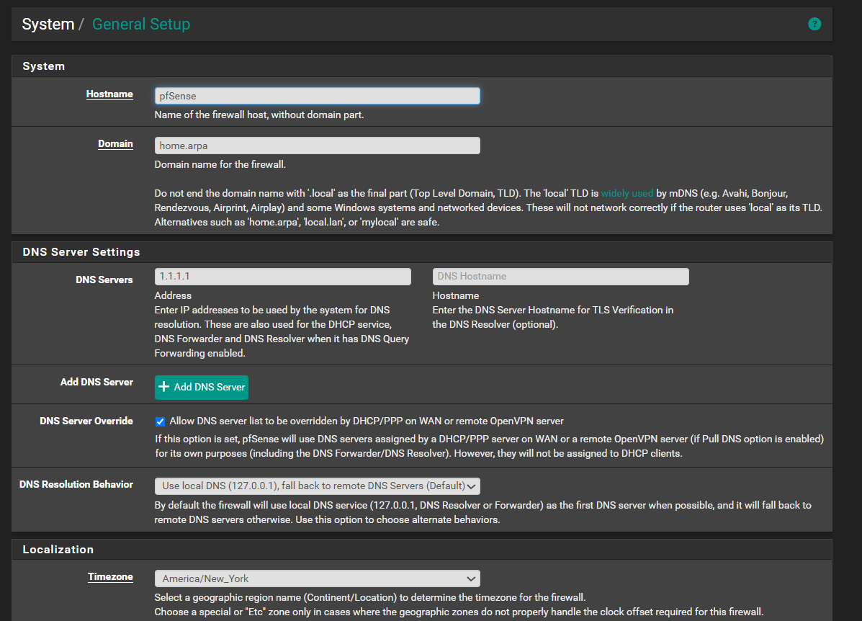

WAN Configuration Screenshots
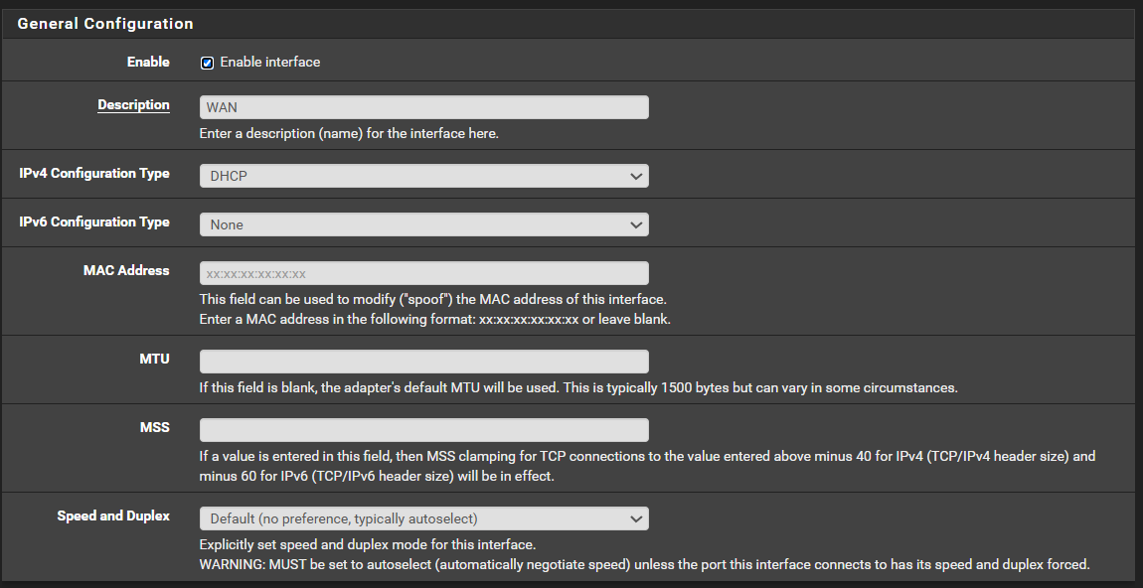
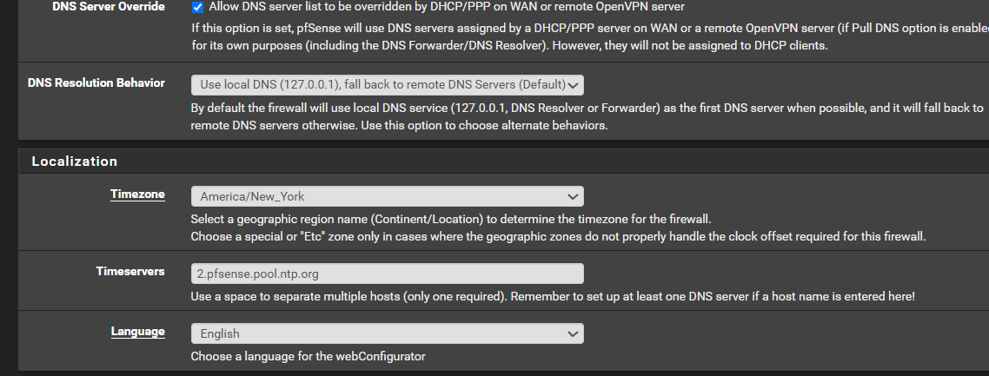

LAN Configuration Screenshots

